Title: **Biodiversity conservation in an uncertain world**

Authors: Richard Schuster a,b,*, Rachel Buxtona, Jeffrey O. Hansona, Allison D. Binleya, Jeremy Pittmanc, Vivitskaia Tullochd, Frank A. La Sortee, Peter H. Verburgf, Amanda D. Rodewalde,g, Scott Wilsona,h, Hugh P. Possinghami, Joseph R. Bennetta

Affiliations:

a Department of Biology, 1125 Colonel By Drive, Carleton University, Ottawa ON, K1S 5B6 Canada.

b Ecosystem Science and Management Program, 3333 University Way, University of Northern British Columbia, Prince George BC, V2N 4Z9 Canada.

cSchool of Planning, University of Waterloo, 200 University Ave W, Waterloo, ON, N2T 3G1, Canada

d Conservation Decisions Lab, Department of Forest and Conservation Sciences, 2424 Main Mall, c

e Cornell Lab of Ornithology, Cornell University, Ithaca, NY 14850, USA

f Institute for Environmental Studies, VU University Amsterdam, Amsterdam, The Netherlands

g Department of Natural Resources and the Environment, Cornell University, Ithaca, NY 14853, USA.

h Wildlife Research Division, Environment and Climate Change Canada, 1125 Colonel By Drive, Ottawa, Ontario, Canada, K1S 5B6

i Centre for Biodiversity and Conservation Science, University of Queensland, St Lucia, Queensland 4067, Australia

*Corresponding author: Department of Biology, 1125 Colonel By Drive, Carleton University, Ottawa ON, K1S 5B6 Canada. Email: [richard.schuster@glel.carleton.ca](mailto:richard.schuster@glel.carleton.ca), Phone: +1 250 631 8324, ORCID: 0000-0003-3191-7869

**First paragraph**

Despite being key instruments in conservation efforts, protected areas are vulnerable to risks associated with (i) weak enforcement and governance1, (ii) pressure from land-use intensification2, and (iii) climate change3, any of which can reduce their effectiveness. Although failing to consider such risk factors in planning diminishes the ability of protected areas to uphold international biodiversity goals4, accounting for them can require additional expenditure. Here we show that plans for expanding the global protected area system that explicitly account for such risks require remarkably small (0.8%) increases in the amount of land protected relative to ignoring risk. Using a multi-objective spatial optimization routine, we developed plans to expand the existing protected area estate – ensuring adequate coverage of all known terrestrial vertebrate species – that accounted for these three categories of risk. Among the three risk categories, governance drove the greatest variation in the location of land prioritized for protection. In particular, conserving wide-ranging species required countries with relatively strong governance to protect more land when bordering nations with comparatively weak governance. Our results both underscore the need for cross-jurisdictional coordination and demonstrate how risk can be efficiently incorporated into global planning efforts.

**Main text**

Protecting habitat is one of the best strategies for stemming the alarming decline of biodiversity5. As such, the cornerstone of the new global framework for biodiversity conservation is to protect at least 30% of terrestrial land area by 20304. Most current approaches for identifying important areas to protect rely upon estimations of the conservation value of the land for biodiversity and the threats it faces4,6,7. Seldom articulated in such plans is the tacit assumption that protection is enforced, effective, and permanent, yet it is well known many protected areas are subject to risks from weak governance, land use intensification, and climate change. For example: the quality of governance relates to investment in conservation8,9; political instability and corruption can reduce protected area effectiveness10,11; protected areas with high deforestation rates are at greater risk of degazettement and failure to meet protection goals12; and increased extreme weather events cause declines and extirpations in native populations13. Thus, to make effective use of limited conservation resources, planning for investment in protected areas must account for these risks14,15. Here we demonstrate how accounting for governance, land-use, and climate risks can influence decisions for establishing protected areas at a global scale and may ultimately improve the resilience of protected areas and the species they support. The risks we consider here represent unstoppable risks that are best avoided, which stand in contrast to stoppable risks that can be abated through effective protected areas management alone16,17.

We defined the following three broad categories of risk, which we considered to be factors likely to diminish the long-term effectiveness of protected areas: (i) governance, (ii) land-use, and (iii) climate. For governance risk, we used a national-scale metric that combines six governance indicators from the World Bank18: accountability, political stability, government effectiveness, regulatory quality, rule of law, and control of corruption (Figure S1). For land-use risk, we estimated the average change in biodiversity per land-use category using methods19 that model the risk of biodiversity loss for land systems due to agricultural expansion and intensification (Figure S2). For climate risk, we used the duration of extreme heat events, calculated using a probabilistic framework that estimates the novelty of temperatures relative to historical year-to-year variation from 1979 to 2019 (Figure S3), identifying areas where heat events are likely to have the most significant effects on biodiversity20. Although we used these three risk categories for illustrative purposes, the approach we propose is flexible and can easily incorporate other risk metrics too21.

We considered the influence of risk categories on allocating protection decisions at a global scale for all 30,930 known distributions of vertebrate species from the IUCN Red List of Threatened Species22 using a multi-objective optimization approach. To incorporate risk categories, we built on a classical problem formulation from the systematic conservation planning literature – the minimum set problem - where the objective is to reach species distribution protection targets, while accounting for one constraint such as land cost or area23–25. We expand this approach to include multiple objectives accounting for varying risk in the problem formulation, by treating each risk layer as a separate objective in the problem formulation26. We use a hierarchical approach that assigns a priority to each objective, and optimizes for the objectives in decreasing priority order. At each step, the approach finds the best solution for the current objective, but only from among those that would not degrade the solution quality for higher-priority objectives.

In total 16 planning scenarios were created, such that solutions accounted for all possible combinations of risk categories within each hierarchical level (Table S1). We then compared these risk-based solutions to those produced with a null scenario that adopted the traditional area-minimizing approach to optimization without considering risk27. Because our scenarios aimed to build upon the current protected area portfolio globally, we incorporated current protected areas into our solutions. For each scenario we protected 30% of the range of all vertebrate species, which is broadly analogous to the more general 30% total area Convention on Biological Diversity (CBD) target27.

Surprisingly, scenarios that incorporated all the three risk categories required only 0.8% more global area on average (0.06 – 1.68 %) than the null scenario to meet the target of protecting 30% of vertebrate ranges. Thus, accounting for risks cost relatively little compared to the potential gains from selecting a more resilient conservation network (Figure 1). Notably, the target of protecting 30% of each vertebrate species range was achieved by all 16 scenarios without exceeding the post-2020 CBD target of protecting 30% of global land area27. When only looking at scenarios that included one risk factor, land-use risk forces the greatest increase in global protected area, compared to scenarios only including governance and/or climate extreme risks (Table S1).

We found that protected areas identified across scenarios overlapped spatially, with the same 11.5 million km2 (7.8% of global land area) being prioritized for expansion of the current protected area system in at least eleven scenarios and 8.5 million km2 (5.8% of global land area) in all fifteen risk scenarios (Figure 2). These “no regrets” areas provide examples of places that should be immediate priorities for international agencies aiming to maximize the resilience of protected area networks, as they are robust to assumptions of the relative importance of risk factors. Example countries that have contiguous areas of high overlap among different scenarios are Canada, Egypt, Finland, Kazakhstan and Peru (Figure S4). There is considerable overlap among the priorities across scenarios within Conservation International’s global biodiversity hotspots28, but many high overlap areas lie either outside these hotspots (53.3%) or occur within small portions of the biodiversity hotspots, likely because these areas are important to protect regardless of future risk (Figure S5).

We also found variation in the locations of priorities for protection when risks were introduced (Figure 3; Table S2). These differences were driven largely by governance (Figure S6). Countries with relatively high governance scores had greater area requiring protection under risk scenarios relative to the null scenario, especially when species were wider ranging and when neighbouring countries had low governance scores. Thus, risk is connected across jurisdictions, where planning scenarios favour protection of species in nearby countries with low governance risk (i.e., high governance scores). For example, many vertebrate species ranges span northeastern Russia, Finland, and Sweden, with one of the most iconic being caribou (*Rangifer tarandus*), which has an IUCN conservation status of vulnerable. Because Russia suffers from low scores for ‘voice and accountability, rule of law, and control of corruption’ (Table S3), whereas Finland and Sweden have relatively high governance scores, the scenarios including governance pressures led to a selection of 99.4% and 48.9% of Finland and Sweden’s land areas respectively compared to the null scenario with 30.8% and 15.2% (Figure 4). These results do not mean the majority of land inside Finland needs to be protected to ensure the long-term persistence of caribou, but indicate that prioritizing areas in Sweden and Finland is predicted to be far less of a risk than areas in Russia.

Land-use and climate change also influenced variation in the locations of priorities for protection compared to the null scenario. For example, large areas of Sierra Leone are experiencing high risk of biodiversity loss due to expanding intensive land-use practices (Fig. S2), whereas this same risk is lower in neighbouring Liberia. Scenarios including land-use risk selected 50.1% of the land area in Liberia compared to 21.9% in the null scenario (Figure 4). Large areas of Algeria are experiencing increasingly frequent extreme heat events (Fig. S3), whereas neighbouring Libya is not experiencing as many extreme heat events. Scenarios including climate impact risk selected of 30.8% of Libya’s land area compared to the null scenario with 20.9% (Figure 4).

These results emphasize the importance of coordinated cross-jurisdictional conservation planning initiatives29 and identify countries where opportunities for collaboration would yield more resilient protected area systems. To illustrate this point, we consider the Great Green Macaw (*Ara ambiguus*), with <2500 individuals remaining30 and a range that stretches from southern Honduras to western Colombia. Because Great Green Macaw habitat spans several countries differing in governance, land use, and climate risk, coordinated efforts among countries will be necessary for the species to persist in the future. For countries with a predominance of wide-ranging species whose ranges will be impacted by varying climate, land-use, and governance risk across borders, conservation projects can focus on cooperative governance frameworks31 (Figure 3). These governance frameworks, both within and between countries, would need to be developed in an environmentally just and equitable way to deliver benefits to biodiversity and local communities32.

In contrast, there is little difference in protection priorities in some countries at high risk from climate change, land-use, and low governance scores, but with high endemism. Given high endemic biodiversity, and homogeneity of risk, these countries all require high rates of protection within their borders. Moreover, some countries closer to reaching the CBD’s 30% land area protection target, for example Brazil, which already has 30.3% of its land area protected, had lower differences between scenarios that incorporate risk and the null scenario that does not incorporate risk, despite having high climate, land-use, and governance risk. This outlines the importance of further considering the effectiveness of existing protected areas in planning analyses, where pressure from cropland conversion in tropical protected areas has increased to similar rates outside protected areas33.

Previous work has incorporated individual risk factors analogous to those we used, including governance1,34, climate change3 and land-use change2,35. Yet, our results show that protected area expansion decisions can be profoundly influenced by all three risk factors combined. If data on risk alters the effectiveness of biodiversity protection, our results show that they should be used together to support decisions for resilient protected area networks. As an example, climate metrics such as disappearing climates36 might be relevant if the consideration is on small-ranged and threatened species. Our flexible framework and methods can allow conservation agencies looking to set priorities from the global to local scale and incorporate different metrics to explore the influence of individual parameters and metrics on decisions.

**Conclusion**

The conservation community has traditionally neglected to estimate how future changes in climate37, land-use35, and socio-economic conditions might compromise the effectiveness of protected areas. Our results show that the spatial distribution of protected areas, rather than the land area *per se*, can be profoundly influenced by risk, particularly from governance. Surprisingly, incorporating risk into decision-making adds <1% to the total global area required to meet biodiversity targets. Accounting for risk comes at limited extra cost, but potentially large benefits to achieving global biodiversity targets. Our results also emphasize the importance of cross-jurisdictional conservation initiatives, especially in adjacent countries sharing wide-ranging species where risk varies considerably from country to country. Considering risk in conservation decision-making will result in more resilient and effective conservation plans into the future to help safeguard our planet’s biodiversity in the face of the current extinction and climate crises.

**Main references**

1. Mascia, M. B. & Pailler, S. Protected area downgrading, downsizing, and degazettement (PADDD) and its conservation implications. *Conserv. Lett.* **4**, 9–20 (2011).

2. Pouzols, F. M. *et al.* Global protected area expansion is compromised by projected land-use and parochialism. *Nature* **516**, 383–386 (2014).

3. Hoffmann, S., Irl, S. D. & Beierkuhnlein, C. Predicted climate shifts within terrestrial protected areas worldwide. *Nat. Commun.* **10**, 1–10 (2019).

4. CBD (Convention on Biological Diversity). Zero draft of the post-2020 global biodiversity framework. https://www.cbd.int/doc/c/efb0/1f84/a892b98d2982a829962b6371/wg2020-02-03-en.pdf (2020).

5. Watson, J. E., Dudley, N., Segan, D. B. & Hockings, M. The performance and potential of protected areas. *Nature* **515**, 67–73 (2014).

6. Brooks, T. M. *et al.* Global biodiversity conservation priorities. *science* **313**, 58–61 (2006).

7. Venter, O. *et al.* Targeting Global Protected Area Expansion for Imperiled Biodiversity. *PLOS Biol.* **12**, e1001891 (2014).

8. Baynham-Herd, Z., Amano, T., Sutherland, W. J. & Donald, P. F. Governance explains variation in national responses to the biodiversity crisis. *Environ. Conserv.* **45**, 407–418 (2018).

9. Miller, D. C., Agrawal, A. & Roberts, J. T. Biodiversity, governance, and the allocation of international aid for conservation. *Conserv. Lett.* **6**, 12–20 (2013).

10. Schulze, K. *et al.* An assessment of threats to terrestrial protected areas. *Conserv. Lett.* **11**, e12435 (2018).

11. Hammill, E., Tulloch, A. I. T., Possingham, H. P., Strange, N. & Wilson, K. A. Factoring attitudes towards armed conflict risk into selection of protected areas for conservation. *Nat. Commun.* **7**, 11042 (2016).

12. Tesfaw, A. T. *et al.* Land-use and land-cover change shape the sustainability and impacts of protected areas. *Proc. Natl. Acad. Sci.* **115**, 2084–2089 (2018).

13. Maxwell, S. L. *et al.* Conservation implications of ecological responses to extreme weather and climate events. *Divers. Distrib.* **25**, 613–625 (2019).

14. McBride, M. F., Wilson, K. A., Bode, M. & Possingham, H. P. Incorporating the effects of socioeconomic uncertainty into priority setting for conservation investment. *Conserv. Biol.* **21**, 1463–1474 (2007).

15. Alagador, D., Cerdeira, J. O. & Araújo, M. B. Shifting protected areas: scheduling spatial priorities under climate change. *J. Appl. Ecol.* **51**, 703–713 (2014).

16. McGowan, J. *et al.* Prioritizing debt conversion opportunities for marine conservation. *Conserv. Biol.* **34**, 1065–1075 (2020).

17. Kuempel, C. D., Jones, K. R., Watson, J. E. M. & Possingham, H. P. Quantifying biases in marine-protected-area placement relative to abatable threats. *Conserv. Biol.* **33**, 1350–1359 (2019).

18. Kaufmann, D., Kraay, A. & Mastruzzi, M. The Worldwide Governance Indicators: Methodology and Analytical Issues1. *Hague J. Rule Law* **3**, 220–246 (2011).

19. Kehoe, L. *et al.* Biodiversity at risk under future cropland expansion and intensification. *Nat. Ecol. Evol.* **1**, 1129–1135 (2017).

20. La Sorte, F. A., Johnston, A. & Ault, T. R. Global trends in the frequency and duration of temperature extremes. *Clim. Change Rev.*

21. Garcia, R. A., Cabeza, M., Rahbek, C. & Araújo, M. B. Multiple dimensions of climate change and their implications for biodiversity. *Science* **344**, 1247579 (2014).

22. IUCN. The IUCN Red List of Threatened Species. version 1.18. (2019).

23. Margules, C. R. & Pressey, R. L. Systematic conservation planning. *Nature* **405**, 243–53 (2000).

24. Moilanen, A., Wilson, K. & Possingham, H. *Spatial conservation prioritization: quantitative methods and computational tools*. (Oxford University Press, 2009).

25. Ball, I. R. R., Possingham, H. P. P. & Watts, M. E. E. Marxan and relatives: Software for spatial conservation prioritisation. in *Spatial conservation prioritisation: Quantitative methods and computational tools.* (eds. Moilanen, A., Wilson, K. & Possingham, H. P.) 185–195 (Oxford University Press, 2009).

26. Deb, K. Multi-objective optimization. in *Search methodologies* 403–449 (Springer, 2014).

27. Post-2020 Global Biodiversity Framework. *IUCN* https://www.iucn.org/theme/global-policy/our-work/convention-biological-diversity-cbd/post-2020-global-biodiversity-framework (2018).

28. Myers, N., Mittermeier, R. A., Mittermeier, C. G., da Fonseca, G. A. B. & Kent, J. Biodiversity hotspots for conservation priorities. *Nature* **403**, 853–858 (2000).

29. Dallimer, M. & Strange, N. Why socio-political borders and boundaries matter in conservation. *Trends Ecol. Evol.* **30**, 132–139 (2015).

30. International), B. I. (BirdLife. IUCN Red List of Threatened Species: Ara ambiguus. *IUCN Red List of Threatened Species* https://www.iucnredlist.org/en (2016).

31. Miller, R. L., Marsh, H., Benham, C. & Hamann, M. A framework for improving the cross-jurisdictional governance of a marine migratory species. *Conserv. Sci. Pract.* **1**, e58 (2019).

32. Martin, A., McGuire, S. & Sullivan, S. Global environmental justice and biodiversity conservation. *Geogr. J.* **179**, 122–131 (2013).

33. Geldmann, J., Manica, A., Burgess, N. D., Coad, L. & Balmford, A. A global-level assessment of the effectiveness of protected areas at resisting anthropogenic pressures. *Proc. Natl. Acad. Sci.* **116**, 23209–23215 (2019).

34. Eklund, J. F. & Cabeza-Jaimejuan, M. D. M. Quality of governance and effectiveness of protected areas: crucial concepts for conservation planning. *Ann. N. Y. Acad. Sci.* (2017).

35. Di Minin, E. *et al.* Global priorities for national carnivore conservation under land use change. *Sci. Rep.* **6**, 23814 (2016).

36. Williams, J. W., Jackson, S. T. & Kutzbach, J. E. Projected distributions of novel and disappearing climates by 2100 AD. *Proc. Natl. Acad. Sci.* **104**, 5738–5742 (2007).

37. Kelly, L. T. *et al.* Fire and biodiversity in the Anthropocene. *Science* **370**, (2020).

**Methods references**

38. Hartigan, J. A. & Wong, M. A. Algorithm AS 136: A K-Means Clustering Algorithm. *J. R. Stat. Soc. Ser. C Appl. Stat.* **28**, 100–108 (1979).

39. Eisenhauer, N., Bonn, A. & A. Guerra, C. Recognizing the quiet extinction of invertebrates. *Nat. Commun.* **10**, 1–3 (2019).

40. Le Saout, S. *et al.* Protected areas and effective biodiversity conservation. *Science* **342**, 803–805 (2013).

41. Butchart, S. H. M. *et al.* Shortfalls and Solutions for Meeting National and Global Conservation Area Targets. *Conserv. Lett.* **8**, 329–337 (2015).

42. Planet, P. Calculating protected area coverage. *Protected Planet* https://www.protectedplanet.net/c/calculating-protected-area-coverage.

43. Coetzer, K. L., Witkowski, E. T. & Erasmus, B. F. Reviewing B iosphere R eserves globally: effective conservation action or bureaucratic label? *Biol. Rev.* **89**, 82–104 (2014).

44. Barnes, M. D. *et al.* Wildlife population trends in protected areas predicted by national socio-economic metrics and body size. *Nat. Commun.* **7**, 12747 (2016).

45. Asselen, S. van & Verburg, P. H. A Land System representation for global assessments and land-use modeling. *Glob. Change Biol.* **18**, 3125–3148 (2012).

46. Hudson, L. N. *et al.* The PREDICTS database: a global database of how local terrestrial biodiversity responds to human impacts. *Ecol. Evol.* **4**, 4701–4735 (2014).

47. Newbold, T. *et al.* Global effects of land use on local terrestrial biodiversity. *Nature* **520**, 45–50 (2015).

48. AghaKouchak, A. *et al.* Climate Extremes and Compound Hazards in a Warming World. *Annu. Rev. Earth Planet. Sci.* **48**, 519–548 (2020).

49. Diffenbaugh, N. S. *et al.* Quantifying the influence of global warming on unprecedented extreme climate events. *Proc. Natl. Acad. Sci.* **114**, 4881–4886 (2017).

50. Anderson G. Brooke & Bell Michelle L. Heat Waves in the United States: Mortality Risk during Heat Waves and Effect Modification by Heat Wave Characteristics in 43 U.S. Communities. *Environ. Health Perspect.* **119**, 210–218 (2011).

51. Battisti, D. S. & Naylor, R. L. Historical Warnings of Future Food Insecurity with Unprecedented Seasonal Heat. *Science* **323**, 240–244 (2009).

52. Mitchell, D. *et al.* Attributing human mortality during extreme heat waves to anthropogenic climate change. *Environ. Res. Lett.* **11**, 074006 (2016).

53. Harris, R. M. B. *et al.* Biological responses to the press and pulse of climate trends and extreme events. *Nat. Clim. Change* **8**, 579–587 (2018).

54. Maron, M., McAlpine, C. A., Watson, J. E. M., Maxwell, S. & Barnard, P. Climate-induced resource bottlenecks exacerbate species vulnerability: a review. *Divers. Distrib.* **21**, 731–743 (2015).

55. Grant, P. R. *et al.* Evolution caused by extreme events. *Philos. Trans. R. Soc. B Biol. Sci.* **372**, 20160146 (2017).

56. Gutschick, V. P. & BassiriRad, H. Extreme events as shaping physiology, ecology, and evolution of plants: toward a unified definition and evaluation of their consequences. *New Phytol.* **160**, 21–42 (2003).

57. Cremonese, E. *et al.* Heat wave hinders green wave: The impact of climate extreme on the phenology of a mountain grassland. *Agric. For. Meteorol.* **247**, 320–330 (2017).

58. Sorte, F. A. L., Hochachka, W. M., Farnsworth, A., Dhondt, A. A. & Sheldon, D. The implications of mid-latitude climate extremes for North American migratory bird populations. *Ecosphere* **7**, e01261 (2016).

59. Fenner, D., Holtmann, A., Krug, A. & Scherer, D. Heat waves in Berlin and Potsdam, Germany – Long-term trends and comparison of heat wave definitions from 1893 to 2017. *Int. J. Climatol.* **39**, 2422–2437 (2019).

60. Smith, T. T., Zaitchik, B. F. & Gohlke, J. M. Heat waves in the United States: definitions, patterns and trends. *Clim. Change* **118**, 811–825 (2013).

61. McPhillips, L. E. *et al.* Defining Extreme Events: A Cross-Disciplinary Review. *Earths Future* **6**, 441–455 (2018).

62. Hersbach, H. *et al.* Global reanalysis: goodbye ERA-Interim, hello ERA5. 17–24 (2019) doi:10.21957/vf291hehd7.

63. Hoffmann, L. *et al.* From ERA-Interim to ERA5: the considerable impact of ECMWF’s next-generation reanalysis on Lagrangian transport simulations. *Atmospheric Chem. Phys.* **19**, 3097–3124 (2019).

64. Huang, N. E. *et al.* The empirical mode decomposition and the Hilbert spectrum for nonlinear and non-stationary time series analysis. *Proc. R. Soc. Lond. Ser. Math. Phys. Eng. Sci.* **454**, 903–995 (1998).

65. Wu, Z., Huang, N. E., Long, S. R. & Peng, C.-K. On the trend, detrending, and variability of nonlinear and nonstationary time series. *Proc. Natl. Acad. Sci.* **104**, 14889–14894 (2007).

66. Ferrari, S. & Cribari-Neto, F. Beta Regression for Modelling Rates and Proportions. *J. Appl. Stat.* **31**, 799–815 (2004).

67. Simas, A. B., Barreto-Souza, W. & Rocha, A. V. Improved estimators for a general class of beta regression models. *Comput. Stat. Data Anal.* **54**, 348–366 (2010).

Figure 1: Spatial representation of priority areas for protection to account for governance, land use and climate risk. Accounting for these risks to protected area effectiveness to produce more resilient conservation networks would require 29.17% of land surface to protect 30% of threatened species’ ranges.

Figure 2: “No regrets” areas comprising 3.57 million km2 of land that was identified as priority habitat for protection regardless of the risks included in our analysis.

Figure 3: Percent country-level variation between the null scenario and the 15 scenarios including risk. Countries whose results are consistent across the 15 scenarios (e.g. Brazil) have low variation, while countries whose results are less consistent across the 15 scenarios have high variation (e.g. Sweden). The kmeans method38 was used to generate class intervals for visualization.



Figure 4: Contrast of using individual risk objectives (governance, land-use, climate) to the null scenario of uniform objective structure. The top panels represent the individual risk data for the focal regions. In the bottom panels brown shows null, green the specific risk objective scenario results, and purple where both scenarios agree. The figures show how the spatial configuration of the solutions changes when risk is considered in a scenario. Governance focus is on Sweden, Finland and Russia, land-use risk on Sierra Leone and Liberia, and climate risk on Algeria and Liberia.

**Methods**

We used a multi-objective optimization approach that incorporated governance, land use and climate constraints to prioritize the conservation of 30,930 vertebrate species. All scenarios we investigated assumed the current global protected area portfolio is locked in. We further set a target to protect 30% of the range of each species, which is broadly analogous to current CDB discussions on post-2020 biodiversity targets4.

*Species selection*

Our species list included all terrestrial vertebrate species from the IUCN Red List of threatened species, following Pouzols et al.2. For mammal, amphibian and reptile species ranges, we used the IUCN Red List website (<http://www.iucnredlist.org/>, accessed 2019-11-14) and for birds we used the BirdLife International data zone webpage (<http://www.birdlife.org/datazone/home>, accessed 2019-11-14). We used these taxa because no analogous data are available for a high proportion of species in other taxonomic groups such as insects39. These data have certain limitations, including possible underestimation of the extent of occurrence and overestimation of the true area of occupancy2, but they have been shown to be robust to commission errors as long as the focus is on species assemblages rather than single species7. They are currently the most frequently used and updated source for vertebrate species distributions40.

For each taxonomic group, we restricted our analysis to species that fell into the presence category of ‘Extant’, the origin categories of ‘Native’ or ‘Reintroduced’ and the seasonality categories ‘Resident’, ‘Breeding Season’ or ‘Non-breeding Season’, thus only focusing on stationary periods of the life cycle of migratory species. This resulted in the following final numbers of amphibian, bird, mammal and reptile species ranges: 5660, 13375, 5442, and 6153, respectively.

*Basic administrative delineations*

National boundaries were derived from the Global Administrative Areas database (<http://gadm.org/>, accessed 2019-10-31). We obtained protected area boundaries from the World Database on Protected Areas (WDPA, [https://www.protectedplanet.net](https://www.protectedplanet.net/)). Following standard procedures for cleaning the protected area dataset41,42, we (i) projected the data to an equal-area coordinate system (World Behrman), (ii) excluded reserves with unknown or proposed designations, (iii) excluded UNESCO Biosphere Reserves43, (iv) buffered sites represented as point localities to their reported area, (v) dissolved boundaries to prevent issues with overlapping areas, and (vi) removed slivers (code available at https://github.com/jeffreyhanson/global-protected-areas). After the protected area data were modified as described above, we overlaid the protected area boundaries with a 10 x 10 km grid covering the Earth. These spatial data procedures were implemented using ArcMap (version 10.3.1) and python (version 2.7.8).

*Governance risk*

Conservation risk due to governance can affect the outcomes of strategies, and effective governance can promote the resilience of conservation in the face of sociopolitical and economic shocks. We used worldwide governance indicators from the World Bank18 to capture these pressures. The indicators include six scaled measures: voice and accountability; political stability and absence of violence; government effectiveness; regulatory quality; rule of law; and control of corruption (see Table S4 for definitions). We chose these indicators because evidence suggests that they reliably predict protected area effectiveness44 and state investment and efforts for biodiversity conservation8. For each country, we used a mean of annual averages of all six measures8 (Figure S1).

*Land use risk*

We used a recently developed global land systems map produced by Kehoe et al.19 to incorporate the risk of land-use change. This map is based on a global land systems map for the year 200045 at a 9.25 km2 spatial resolution, but is refined based on recent land-cover and land-use datasets to a spatial resolution of 1 km2. Kehoe et al.19 further estimated the impact of land use and land use intensity on biodiversity, with data originating from the PREDICTS project46. They first matched their land-systems classes to varying intensity levels for each land-use type (for detailed conversion table, see ref47). This allowed Kehoe et al.19 to calculate average biodiversity loss per land system (relative to an unimpacted baseline) by taking the mean model estimates of biodiversity loss per land-use intensity class from previous work47. The result gives average relative biodiversity gain or loss per land-system class. Here, we used their modelled mean estimates (following Newbold et al.47) of relative percent biodiversity change for each land-system class for species abundance as a measure of the land-use pressure (Figure S2).

*Climate risk*

Anthropogenic climate change is affecting the frequency and duration of extreme heat events48,49. Exposure to these events can adversely affect human populations50–52 and natural systems13,53. For species in natural systems, these events can further the decline and extirpation of populations, increasing the chances of extinction13,54. EHE and ECE can also promote the formation of novel ecosystems53, generate enhanced selection pressures55,56, and change the phenology of life history events57,58. There are a number of climate indices that have been used to estimate the occurrence of these events59,60. These indices are often context specific and there is little consensus on the most appropriate technique61.

We estimated climatic risk based on the estimated trend in the annual proportion of days containing extreme heat events from 1979 to 201917. Extreme heat events were estimated using hourly air temperature at 2 m above the surface and gridded at a 31 km (0.28125° at the equator) spatial resolution (DOI: 10.24381/cds.adbb2d47). The temperature data was acquired from the European Centre for Medium-Range Weather Forecasts (ECMWF) fifth generation atmospheric reanalysis of the global climate (ERA5)62,63. The approach first extracted daily minimum and maximum temperature for each grid cell over the 41-year period. To reduce the influence of warming trends, the daily minimum and maximum temperature was then detrended across years for each day and grid cell using empirical mode decomposition (EMD)64,65. The occurrence of extreme heat events was estimated using the following approach: The detrended minimum and maximum temperature data was treated as normally distributed across years for each day and grid cell. The probability density function for the detrended minimum and maximum temperature was then estimated using the mean and standard deviation calculated across years for each day and grid cell. Extreme heat events occurred when the probabilities for both minimum and maximum temperature on a given day and grid cell were within the 0.95-1.00 quartile of the probability density function. The trend in the annual proportion of days containing extreme heat events for each year was calculated for each grid cell using beta regression with a logit link function and an identity function in the precision model66,67. (Figure S3). See La Sorte et al.20 for additional details.

*Multi-objective optimization of pressure reduction*

We processed all data described previously to a 10 x 10 km resolution and clipped data to the extent of land based on the global administrative areas database. We then developed an extension on the minimum set problem, which has the goal to identify a set of sites within a planning area that represents all conservation targets in the fewest number of sites24. Instead of including a single objective in the problem formulation, we expanded it to include multiple objectives. Specifically, we used a hierarchical (lexicographic) approach that assigns a priority to each objective, and sequentially optimizes for the objectives in order of decreasing priority. At each step, it finds the best solution for the current objective, but only from among those that would not degrade the solution quality for higher-priority objectives. We considered up to three objectives in our prioritization scenarios, i) governance risk, ii) land-use risk, and iii) climate risk. To compare different scenarios, we calculated solutions for each unique objective combination (n = 15), as well as one where we use a constant objective function as the null scenario, as the order of the hierarchy can influence the results.

In systematic conservation planning, conservation features describe the biodiversity units (e.g., species, communities, habitat types) that are used to inform protected area establishment. Planning units describe the candidate areas for protected area establishment (e.g., cadastral units). Each planning unit contains an amount of each feature (e.g., presence/absence, number of individuals). A prioritization describes a candidate set of planning units selected for protected establishment. Each feature has a representation target indicating the minimum amount of each feature that ideally should be held in the prioritization (e.g., 50 presences, 200 individuals). To minimize risk, we have a set of datasets describing the relative risk associated with selecting each planning unit for protected area establishment. Thus, we wish to identify a prioritization that meets the representation targets for all of the conservation features, with minimal risk.

Let I denote the set of conservation features (indexed by i), and J denote the set of planning units (indexed by j). To describe existing conservation efforts, let pj indicate (i.e., using zeros and ones) if each planning unit j ∈ J is already part of the global protected area system. To describe the spatial distribution of the features, let Aij denote (i.e., using zeros and ones) if each feature is present or absent from each planning unit. To ensure the features are adequately represented by the solution, let ti denote the conservation target for each feature i ∈ I. Next, let D denote the set of risk datasets (indexed by d). To describe the relative risk associated with each planning unit, let Rdj denote the risk for planning units j ∈ J according to risk datasets d ∈ D.

The problem contains the binary decision variables xj for planning units j ∈ J.

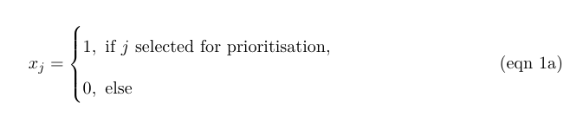

The reserve selection problem is formulated following:

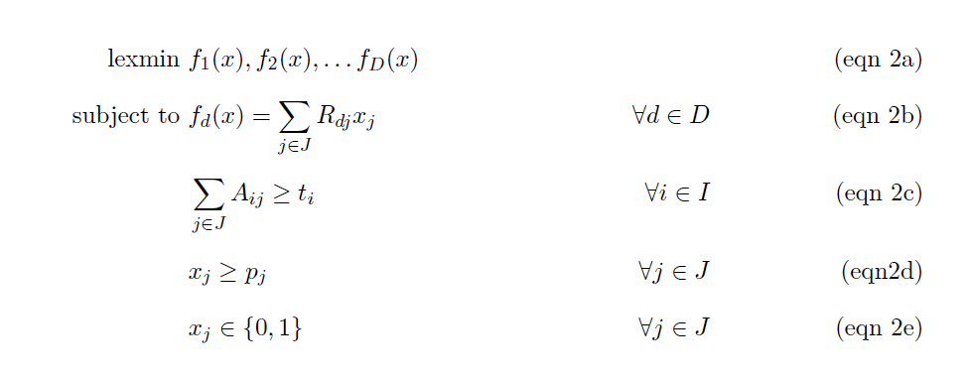

The objective function (eqn 2a) is to hierarchically (lexicographically) minimize multiple functions. Constraints (eqn 2b) define each of these functions as the total risk encompassed by selected planning units given each risk dataset. Constraints (eqn 2c) ensure that the representation targets (ti ) are met for all features. Constraints (eqn 2d) ensure that the existing protected areas are selected in the

solution. Finally, constraints (eqns 2e) ensure that the decision variables xj contain zeros or ones.

For all scenarios we locked in current protected areas and used the same feature set of 30,930 vertebrates. The target for each feature was set to 30% of their range. The optimality gap, which specifies how far from numerical optimality we would allow the solution to be, was 10% for each objective in the hierarchy. We chose a 10% optimality gap to allow for some flexibility in the result of each step in the hierarchy to avoid getting too restricted in the solution space.

**Acknowledgements**

R. Schuster was supported by a Liber Ero Postdoctoral Fellowship, the Nature Conservancy of Canada, and Environment and Climate Change Canada (ECCC), R. Buxton by ECCC, J. Hanson by ECCC and the Natural Sciences and Engineering Research Council of Canada (NSERC), A. Binley by ECCC and an Ontario Graduate Scholarship, V. Tulloch by a Postdoctoral Research Grant from ECCC, J. Bennett by NSERC and ECCC.

**Author contributions**

R.S., R.B. and J.B. designed the study. R.S., R.B., J.O.H., J.P., and F.A.LS. obtained the data. R.S. performed the analysis. R.S. and R.B. drafted the manuscript. All authors discussed the results, contributed critically to the drafts, and gave final approval for publication.

**Competing interest declaration**

No competing interests to declare

**Data availability**

All data, scripts and full results are available on Open Science Framework (OSF) and will be assigned a DOI once the manuscript is in print: <https://osf.io/e2fuw/?view_only=46eb2e525daf42d29df318a92762d885>

**Table S1.** Scenarios explored and global protection results. The risk factor order represents the order risk factors were included in the hierarchical prioritization. (G = governance, L = land use, C = Climate).

|  |  |  |
| --- | --- | --- |
| **Scenario** | **Risk factors included** | **Global land area protected [%]** |
| **null** | - | 21.32 |
| **1** | G | 21.39 |
| **2** | L | 22.36 |
| **3** | C | 22.98 |
| **4** | G > L | 21.96 |
| **5** | L > G | 22.36 |
| **6** | G > C | 21.38 |
| **7** | C > G | 23 |
| **8** | L > C | 21.91 |
| **9** | C > L | 22.33 |
| **10** | G > L > C | 21.7 |
| **11** | G > C > L | 21.38 |
| **12** | L > G > C | 21.91 |
| **13** | L > C > G | 21.91 |
| **14** | C > G > L | 22.33 |
| **15** | C > L > G | 22.33 |

**Table S2**. Country specific results for the 15 scenarios investigated. Numbers represent % of land area of a country selected.  
(As an example 5 countries included here, full list in csv. N = null, G = governance, L = land use, C = Climate)   
<https://drive.google.com/file/d/1eD4y4K8XG4nxnRL5fNtiTqzuqfIJ_DfB/view?usp=sharing>

|  |  |  |  |  |  |
| --- | --- | --- | --- | --- | --- |
|  | Afghanistan | Akrotiri and Dhekelia | Åland | Albania | Algeria |
| N | 15.98 | 100 | 53.85 | 38.41 | 10.39 |
| G | 14.92 | 100 | 69.23 | 36.68 | 7.73 |
| L | 17 | 100 | 76.92 | 43.25 | 9.26 |
| C | 18.38 | 100 | 84.62 | 39.45 | 10.97 |
| GL | 15.81 | 100 | 76.92 | 38.41 | 8.91 |
| LG | 16.98 | 100 | 76.92 | 43.25 | 10.04 |
| GC | 15.12 | 100 | 76.92 | 36.68 | 7.8 |
| CG | 18.17 | 100 | 84.62 | 39.45 | 10.97 |
| LC | 17.17 | 100 | 53.85 | 41.87 | 10 |
| CL | 17.02 | 100 | 76.92 | 43.6 | 13.46 |
| GLC | 16.08 | 100 | 84.62 | 38.06 | 8.79 |
| GCL | 15.12 | 100 | 76.92 | 36.68 | 7.8 |
| LGC | 17.34 | 100 | 61.54 | 40.83 | 10.03 |
| LCG | 17.17 | 100 | 53.85 | 41.87 | 10 |
| CGL | 17.03 | 100 | 76.92 | 43.6 | 11.05 |
| CLG | 17.02 | 100 | 76.92 | 43.6 | 13.46 |

**Table S3. Governance risk score table (see csv)**<https://drive.google.com/file/d/1g_LePBfCbphXzTiCOXCzQtNLSSYoV6me/view?usp=sharing>

**Table S4.**

|  |  |
| --- | --- |
| **Indicator** | **Definition**  Source: World Bank, 2020 (<https://datacatalog.worldbank.org/dataset/worldwide-governance-indicators>) |
| Voice and accountability | “Voice and accountability captures perceptions of the extent to which a country's citizens are able to participate in selecting their government, as well as freedom of expression, freedom of association, and a free media.” |
| Political stability and absence of violence | “Political Stability and Absence of Violence/Terrorism measures perceptions of the likelihood of political instability and/or politically-motivated violence, including terrorism.” |
| Government effectiveness | “Government effectiveness captures perceptions of the quality of public services, the quality of the civil service and the degree of its independence from political pressures, the quality of policy formulation and implementation, and the credibility of the government's commitment to such policies.” |
| Regulatory quality | “Regulatory quality captures perceptions of the ability of the government to formulate and implement sound policies and regulations that permit and promote private sector development.” |
| Rule of law | “Rule of law captures perceptions of the extent to which agents have confidence in and abide by the rules of society, and in particular the quality of contract enforcement, property rights, the police, and the courts, as well as the likelihood of crime and violence.” |
| Control of corruption | “Control of corruption captures perceptions of the extent to which public power is exercised for private gain, including both petty and grand forms of corruption, as well as "capture" of the state by elites and private interests.” |

**Figure S1. Governance risk (yellow = low, blue= high)**

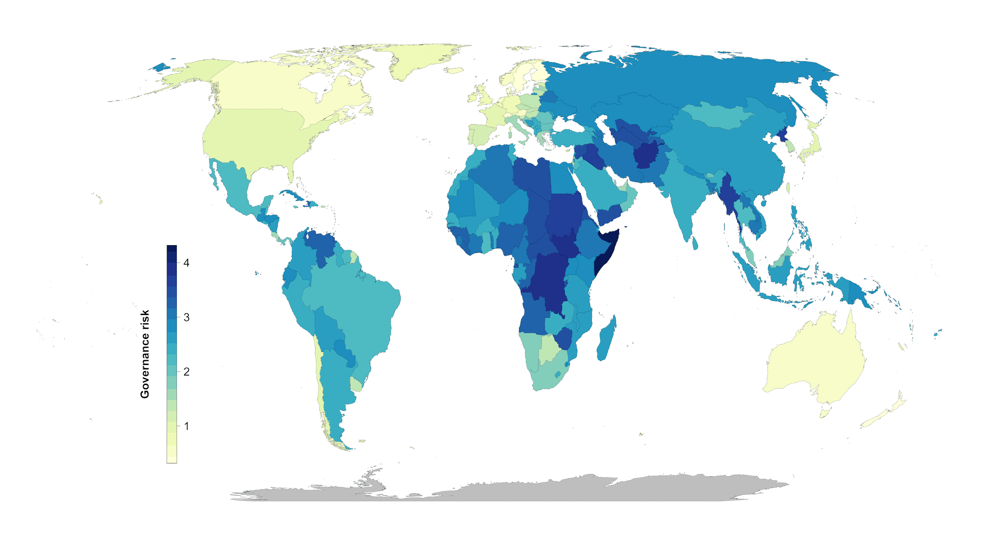

**Figure S2. Land systems risk (yellow = low, blue= high)**

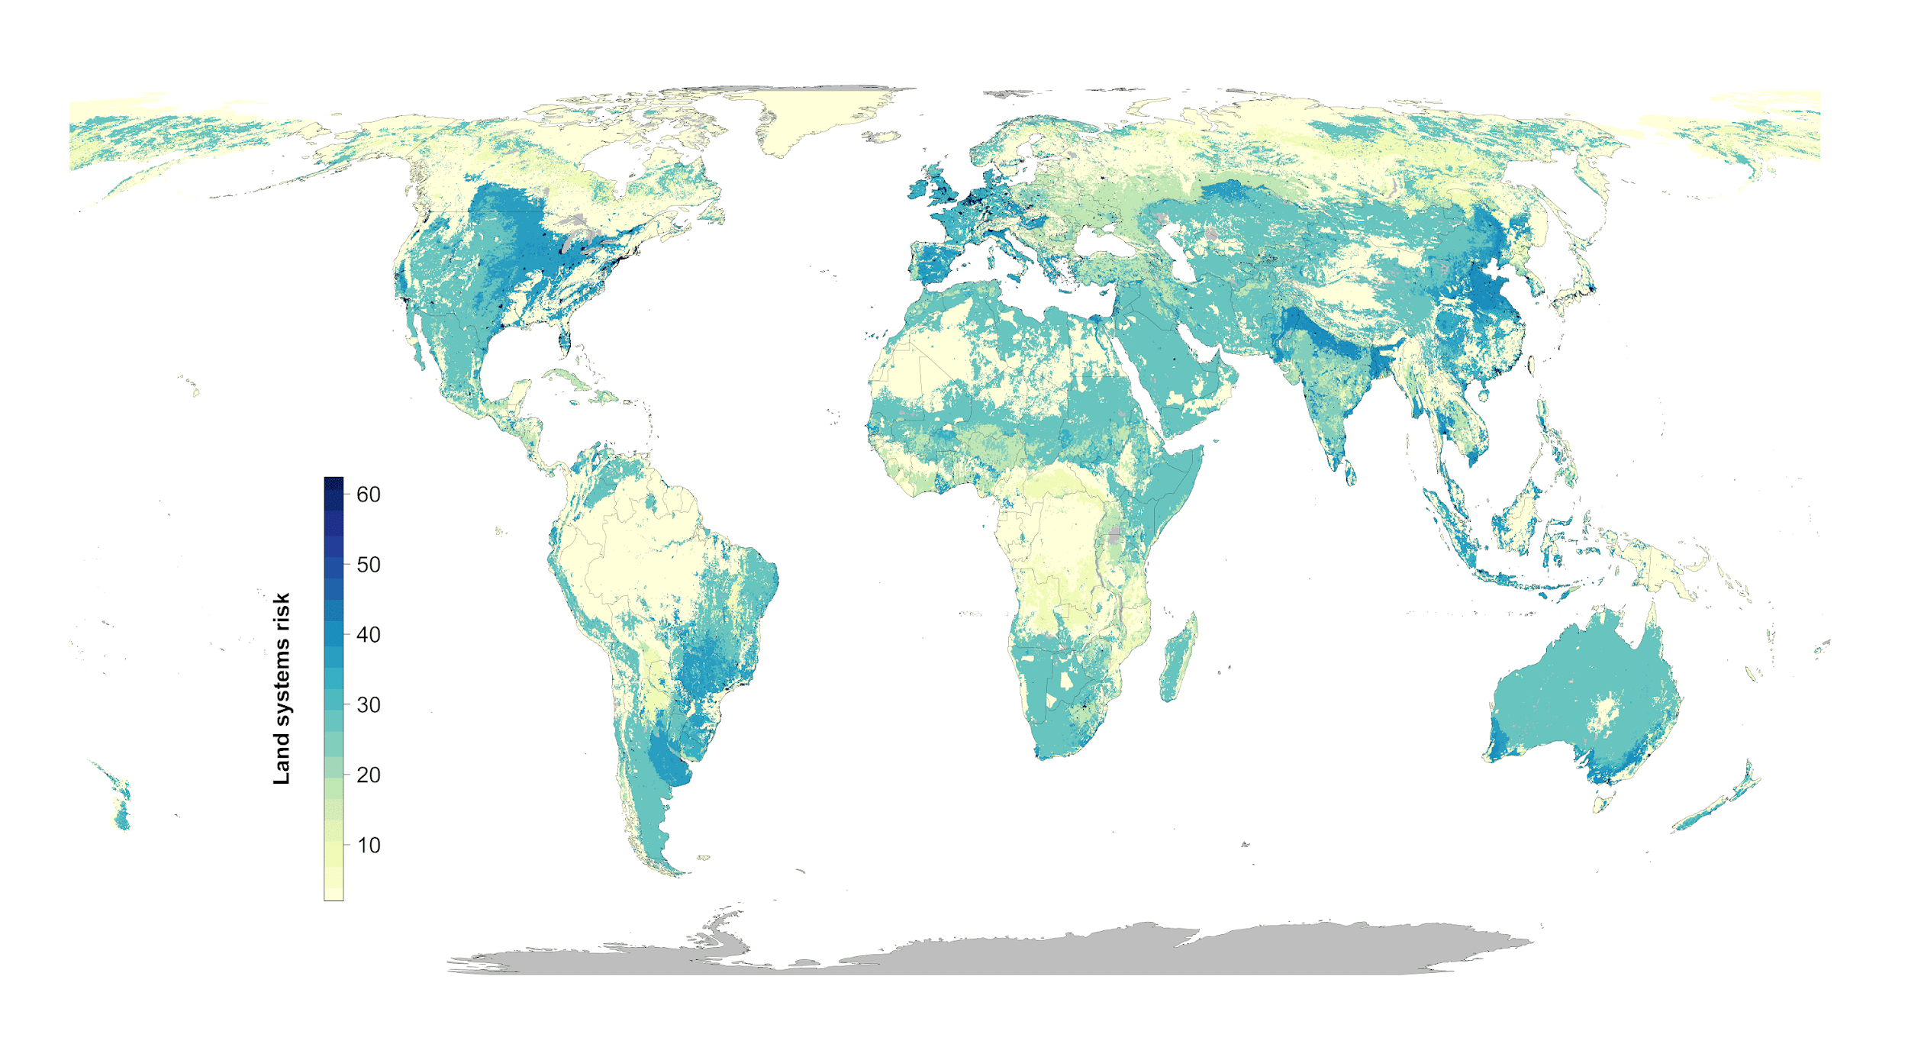

**Figure S3. Climate risk (extreme heat events) (yellow = low, blue= high)**

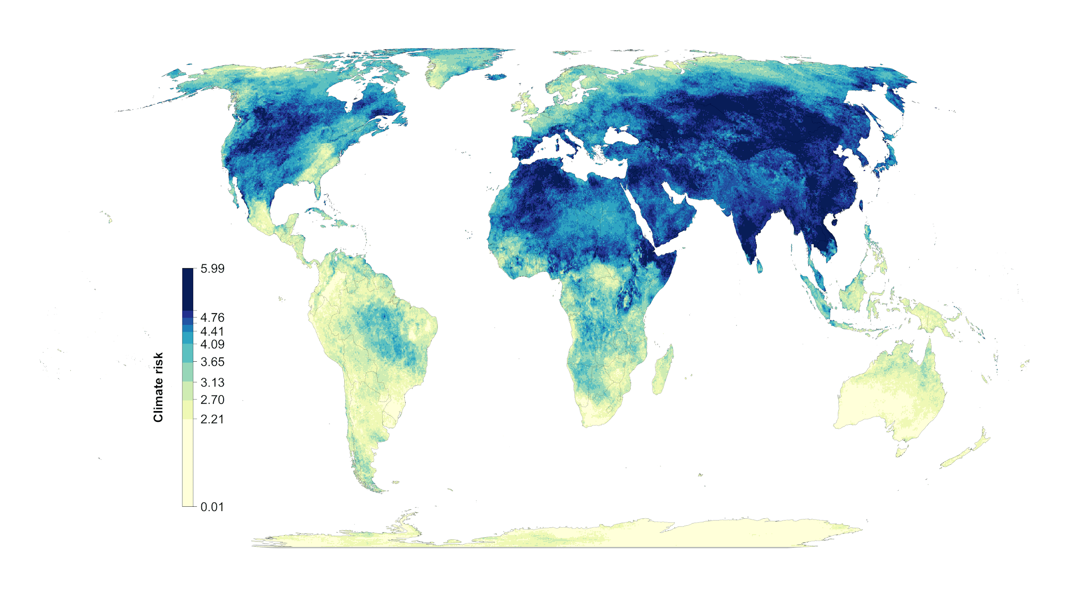

**Figure S4: Scenario overlap. green = protected areas. Color gradient from yellow (one scenario) to red (15 scenarios) = ovelap.**



**Figure S5. Areas of high scenario overlap (>10 scenarios, green) compared to Meyers et al. biodiversity hotspots (blue).**

**Figure S6: Influence of average country specific risk factors on the optimization outcomes compared between null scenario and the scenarios including one of the risk factors. Each data point represents the results for one country. The fitted blue lines and 95% confidence bands are from ordinary least-squares regression.**

